caNanoLab – cancer Nanotechnology Laboratory Analysis Bench

Software Design Description

Release 1.1

Document Change Record
Version Number | Date | Description
1.1 | 02/15/07 | Initial document

TABLE OF CONTENTS
Software Design Description i
Release 1.1 i
1. Introduction 1
1.1 PROJECT BACKGROUND 1
1.2 identification 2
1.3 Requirements 2
1.4 System Overview 2
1.5 Document Overview 2
1.6 Reference documents 4
2. System Architecture 5
2.1 caNanolab Grid Node 5
2.1.1 caNanoLab Application 5
2.1.2 caNanoLab Business Service 6
2.1.3 caNanoLab SDK Data Service 6
2.1.4 caNanoLab Grid Data Service 6
2.2 caGrid Index Service 6
3. Components 7
3.1 User Interface 7
3.2 Service layer 8
3.2.1 Remote Query Facade 8
3.2.2 Public Data Filter 9
3.2.3 Remote File Content Retrieval 11
3.2.4 caNanoLab Grid Data Service 11
3.3 BACK END 12
3.3.1 Domain Classes 12
3.3.2 Database Design 12
3.3.3 Views 12
3.3.4 Indexes 12
Appendix A – acronym List 13

Introduction
The purpose of this document is to describe the design for the cancer Nanotechnology Laboratory Analysis Bench (caNanoLab) Release 1.1, the gridified extension of 1.0 release.

PROJECT BACKGROUND
The caNanoLab effort is collaboration between the NCICB and the Nanotechnology Characterization Laboratory (NCL) facilitating the development of standards supporting nanotechnology in medicine. The NCL performs and standardizes the characterization of nanomaterials intended for cancer therapeutics and diagnostics. One of the goals of the collaboration is the establishment of nanoparticle characterization standards in support of data sharing with the Cancer Centers of Nanotechnology Excellence (CCNEs) and caBIG™ participants.

Working towards this data sharing goal, the caNanoLab 1.1 effort involves connecting existing caNanoLab 1.0 data services to the caBIG grid (caGrid™). Connecting caNanoLab data services will enable data sharing amongst CCNEs and the nanotechnology community in a federated approach.

Release 1.1 features include:
- Auto discover grid node – Using caGrid index server to automatically discover active caNanoLab nodes.
- Remote Nanoparticle Search – Searching for publicly available nanoparticles from remote caNanoLab data services connected to the caBIG grid (caGrid)
- Remote Report Search – Searching for publicly available nanoparticle reports from remote caNanoLab data services connected to the caBIG grid (caGrid)

identification
The system identification information to which this document applies is as follows:
- Title: cancer Nanotechnology Laboratory Analysis Bench
- Abbreviation: caNanoLab
- Version: 1.0
- Release Number: 1.1

Requirements
The following is a list of high-level functional and technical requirements for caNanoLab 1.1:
Req. # | Requirement
1.0 | The system shall allow Researchers to search remote caNanoLab nodes connected to the caBIG grid (caGrid)
1.1 | The system shall allow researchers to query for publicly available nanoparticles from remote caNanoLab nodes on the grid
1.1.1 | The system shall allow Researchers to obtain nanoparticle search results including general information about a nanoparticle and particle composition
1.2 | The system shall allow researchers to query for publicly available reports from remote caNanoLab nodes on the grid
1.2.1 | The system shall allow Researchers to obtain report search results including general information about a report and the report file
2.0 | The system shall allow Clients to discovery and query services via the caBIG grid (caGrid)
2.1 | The system shall advertise data services defined in the caNanoLab object model (nano-OM) to the caBIG Grid for discovery/retrieval
2.2 | The system shall allow client APIs to query caNanoLab data services via the caBIG Grid
2.3 | The system shall allow client APIs to obtain public data only from caNanoLab nodes

Table 1-1: Requirements Matrix
These requirements are further expanded in the caNanoLab 1.0 Use Case Specification.

System Overview
The primary goals of the caNanoLab Release 1.1 effort are to:
- Publish caNanoLab domain model on caGrid
- Enhance caNanoLab application to allow user to search data from active caNanoLab grid nodes

Operations and Maintenance
caNanoLab 1.1 is being deployed and maintained at the Advanced Biomedical Computing Center (ABCC) in NCI Frederick for use at the NCL.

Key Stakeholders
Key stakeholders associated with the effort are defined as follows:

- Nanotechnology Characterization Laboratory (NCL) – End users of the caNanoLab system
- Cancer Centers of Nanotech Excellence (CCNEs) – Consumers of caNanoLab data
- Advanced Biomedical Computing Center (ABCC) – Provides caNanoLab operations and maintenance support
- National Cancer Institute Center for Bioinformatics (NCICB) – Provides development and metadata support

Document Overview
This document provides an overview of caNanoLab system design. It is intended to describe and capture the caNanoLab design decisions and is written as a reference for both the NCI customer and the NCI contractors/developers involved with the evolution of caNanoLab. This is a living document and will be updated to reflect the evolution of development, as well as future enhancements and upgrades.
The main sections of this document are listed and described below.
- Section 1. Introduction: provides a purpose statement, project background, requirements matrix, system overview, and document overview.

- Section 2. System Architecture: Describes an overview of the system, the conceptual and architectural design, interfaces, and the various environments that will be used throughout the development lifecycle.
- Section 3. Components: Identifies and describes each component broken down into its parts that are described in detail.

Reference documents
Document Name | Version | Location
caNanoLab 1.1 Use Case Specification | 1.0 | CVS Server: cbiocvs2; Module: caNanoLab; Directory: doc/usecase
caNanoLab 1.- Architecture Checklist | 1.0 | NCICB CM team
caCORE SDK and CSM | 1.1 | Refer caCORE Technical guide for the design document. ftp://ftp1.nci.nih.gov/pub/cacore/SDK/caCORE_SDK1.0.3_Programmers_Guide.pdf
caBIG Compatibility Guidelines | 2.0 | https://cabig.nci.nih.gov/guidelines_documentation/caBIGCompatGuideRev2_final.pdf
caGrid 1.0 User Guide |  | http://gforge.nci.nih.gov/frs/download.php/1416/caGrid-1-0_Users_Guide.pdf
caGrid 1.0 Programmer Guide |  | http://gforge.nci.nih.gov/frs/download.php/1417/caGrid-1-0_Programmers_Guide.pdf

Table 1-2: Reference Documents

System Architecture
The caNanoLab Grid Enabling Architecture is based on an n-tier computing environment that assigns responsibilities to separate application layers. This fosters a loosely coupled and tightly cohesive architecture in which objects in each layer are focused on specific architectural responsibilities yet, cleanly integrate with the other layers.

The purpose of this section is to give an overview of the caNanoLab 1.1 architecture. The following diagram shows the overall architecture of caNanoLab 1.1. An overview of each component is provided in the sections immediately following the diagram.

caNanoLab
APP
Remote
Query
Facade
caCORE SDK
Data Services
File
System
caBIG™
caGrid

(Data, Discovery,
Query Services)
caNanoLab
Grid Data
Services
caNanoLab
Local (DTOs)
Business Services
CSM
Index Service
NCL
Node
WU
Node
CaNanoLab
DataBase
Figure 2-1: Grid Enabling Architecture

caNanolab Grid Node
Each caNanoLab Grid Node consists caNanoLab Application(POJOs, ORMs, DTOs, application business services), caNanoLab SDK Data Service(POJOs, ORMs, SDK ApplicationService), caNanoLab Grid Data Service, Database, File System, and CSM User Provisioning Tool.

caNanoLab Application
caNanoLab application is a web-based application. Users (researchers) access application through commonly available web browser software using the HTTP protocol.
Java Server Pages (JSPs) are used to generate dynamic HTML (DHTML) based on user actions. JSPs are a combination of HTML, Java Code, and custom JSP tags that get compiled into Servlet classes. The Java Server Pages Standard Tag Library (JSTL) provides a library of commonly used web based functionality to facilitate re-use.
The Struts Framework is used to separate the presentation and business logic and the Tiles framework is used to create reusable page components.

caNanoLab Business Service
caNanoLab business service layer is the middle tier responsible for bridging the gap between the user interface that presents data and the back end that retrieves and stores the data. RemoteQueryFacade is added to this layer in order to filter the non-public data and retrieve the file content from local file system.

caNanoLab SDK Data Service
The caNanoLab SDK Data Service is packaged by caCORE SDK 3.1 with customized Domain Object (POJOs) and Hibernate ORM mapping files.
The caCORE Software Development Kit (SDK) provides a robust set of tools for accessing domain object data using Java. Based on a Unified Modeling Language (UML) model of the domain classes and database structure, the SDK generates a Data Service that provides access to the data represented by the modeled domain classes.

caNanoLab Grid Data Service
caNanoLab Grid Data Service is generated by Introduce toolkit. Additional operations have been added to the generic data service for caCORE SDK Data Source to fulfill the web application needs.

caGrid Index Service
caGrid Index Service is a central indexing register service where all the grid service(data service or analytical service) register its availability and the service metadata. caNanoLab uses caGrid discovery API to query the caGrid Index Service for the active caNanoLab nodes over the grid at run time.

Components

User Interface
Remote Search tab is created for all application users. It contains Remote Search Nanoparticles and Remote Search Reports.
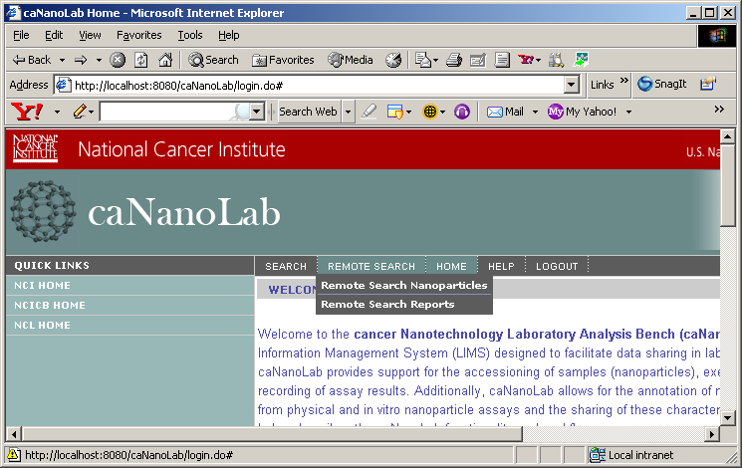
Figure 3-1: Remote Search Tab

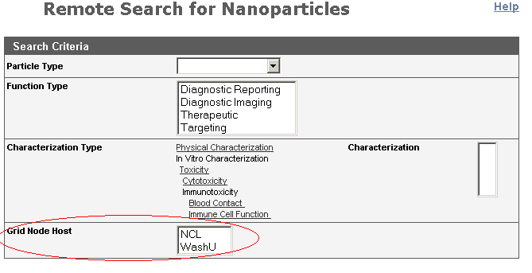
Figure 3-2: Grid Node Auto Discovery
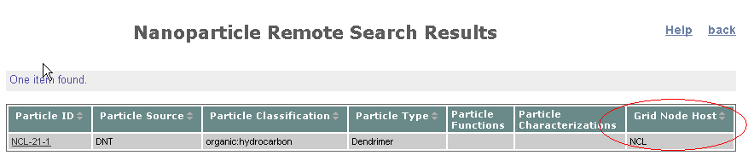
Figure 3-3: Remote Search Result

Service layer

Remote Query Facade
The diagram below illustrates an example interaction using Remote Query Facade. Please note that the sequence is drawn from a specification perspective to provide an overview of the normal sequence between the involved major classes.
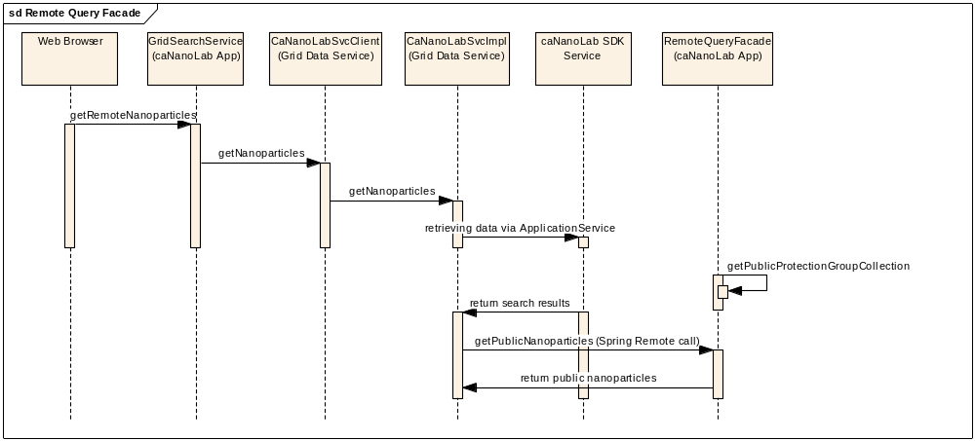
Figure 3-4: Remote Query Sequence Diagram

RemoteQueryFacade is a part of caNanoLab Application package. It is served as public data filter, remote file content retrieval in caNanoLab 1.1 release.
Methods | Parameter list | Return Type
isPublicData | String data | boolean
getPublicNanoparticles | List<String> particlesName | Nanoparticle[]
getPublicReports | List<Report> reports | Report[]
getPublicAssociatedFiles | List<AssociatedFile> associatedFiles | AssociatedFile[]
getPublicOutputFiles | List<OutputFile> files | OutputFile[]
getPublicData | List dataObjects | List
retrievePublicFileContent | Long fileId | byte[]

Public Data Filter
In caNanoLab 1.1, only the public data can be retrieved from the remote search. And the caNanoLab data visibility is controlled by CSM, which is not accessible from Grid Data Service. In order to retrieve CSM protection element and protection group data, the Grid Data Service needs to talk to the local caNanoLab Application that is able to identify what data is public via Spring Remote.
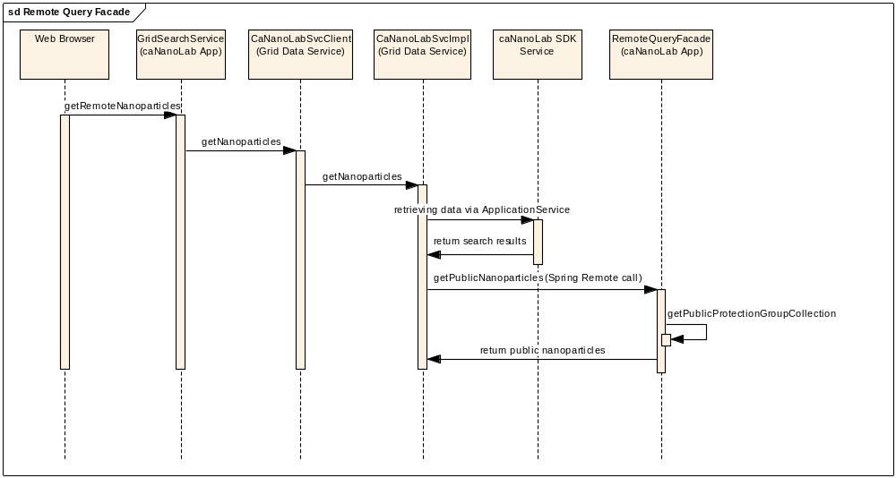
Figure 3-5: Public Data Filter Sequence Diagram

caNanoLab public data filter is implemented in CQLProcess in order to return only public data to other grid client (such as caGrid browser). A customized CQLProcessor (HQLCorePublicQueryProcessor.java) is created for caNanoLab Grid Data Service, and it is specified in the service.properties to replace default CQLProcessor.

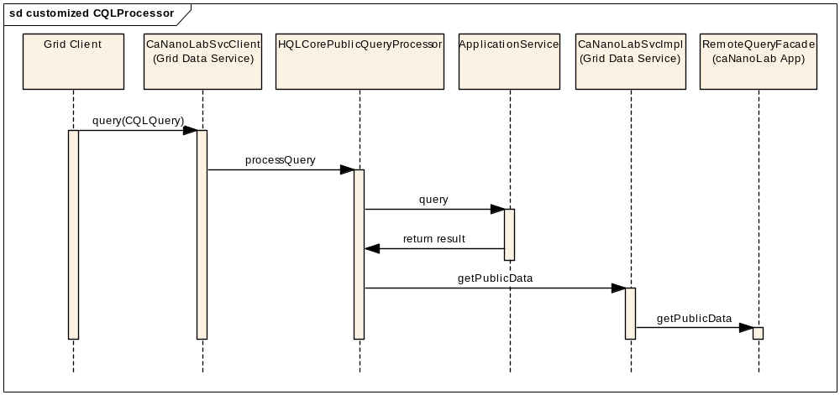
Figure 3-6: Public Data Filter for other Grid Client Sequence Diagram

Remote File Content Retrieval
To download remote file, Spring Remote is used to communicate between two caNanoLab applications. The request application will receive the remote application service URL with the report/associated file search result. With the existing remote application service URL, the request application is directly talking to the remote application to retrieve file content via remote application FileService.

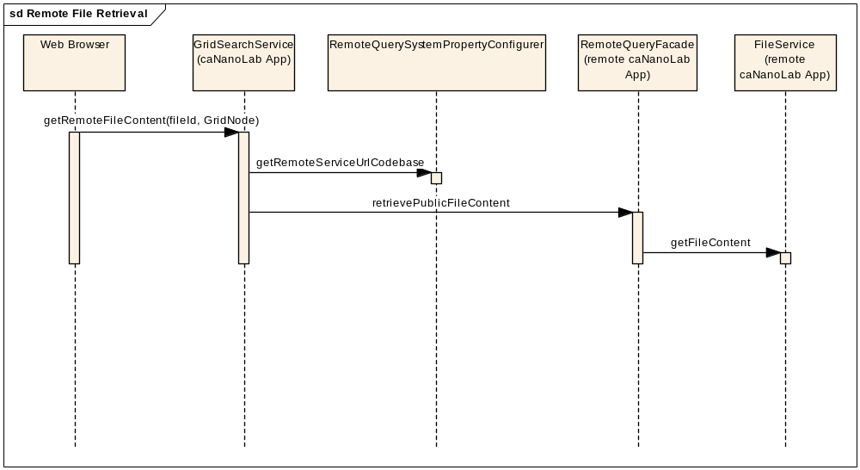
Figure 3-2: Remote File Content Retrieval Sequence Diagram

caNanoLab Grid Data Service
caNanoLab caGrid Data service is generated by cacoreSDK and Introduce toolkit with customized POJO domain objects and hibernate OR mapping files. caNanoLab domain module is published through the Grid Data Service. caNanoLab Grid Data Service also publishes the additional convenient operations as listed below.
Methods | Parameter list | Return Type
getFileContent | Long fileId | byte[]
getNanoparticles | String particleType  String[] characterizationTypes  String[] functionTypes | Nanoparticle[]
getReports | String reportTitle  String particleType  String[] functionTypes | Report[]
getOtherAssociatedFile | String reportTitle  String particleType  String[] functionTypes | AssociatedFile[]
getFunctionsByParticleName | String particleName | Function[]
getCharacterizationsByParticleName | String particleName | Characterization[]
getSourceByParitcleName | String particleName | Source

BACK END

Domain Classes
The following Interface classes have been changed to concrete class in order to use caCORE SDK.
gov.nih.nci.calab.domain.nano.characterization.Characterization
gov.nih.nci.calab.domain.nano.funtion.Linkage
gov.nih.nci.calab.domain.nano.function.Agent
gov.nih.nci.calab.domain.nano..function.AgentTarget
gov.nih.nci.calab.domain.nano.toxicity.Toxicity
gov.nih.nci.calab.domain.nano.toxicity.ImmunoToxicity
gov.nih.nci.calab.domain.nano.toxicity.CytoToxicity

New association has been created between Nanoparticle and Report/AssociatedFile, which replaces the association from Sample to Report/AssociatedFile.

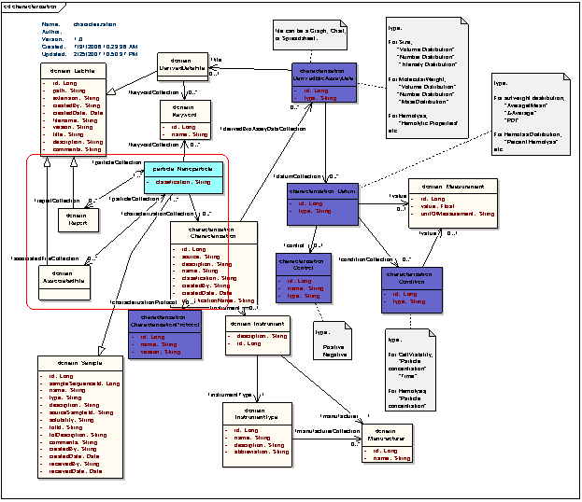

Figure 3-2: UML Model for Characterization Package

Database Design
No changes.

Views
No changes.

Appendix A – acronym List
Acronym | Description
ABCC | Advanced Biomedical Computing Center
caCORE | Cancer Common Ontological Representation Environment
caNanoLab | Cancer Nanotechnology Laboratory Analysis Bench
CCNE | Cancer Center of Nanotechnology Excellence
CSM | Common Security Module
DAO | Data Access Object
DTO | Data Transfer Object
JSP | Java Server Page
JSTL | Java Server Page Tab Library
NCICB | National Cancer Institute Center for Bioinformatics
NCL | Nanotechnology Characterization Laboratory
RDBMS | Relational Database Management System
SDK | Software Development Toolkit
SWDD | Software Design Description
UML | Unified Modeling Language
UPT | User Provisioning Toolkit
CQL | Common Query Language

